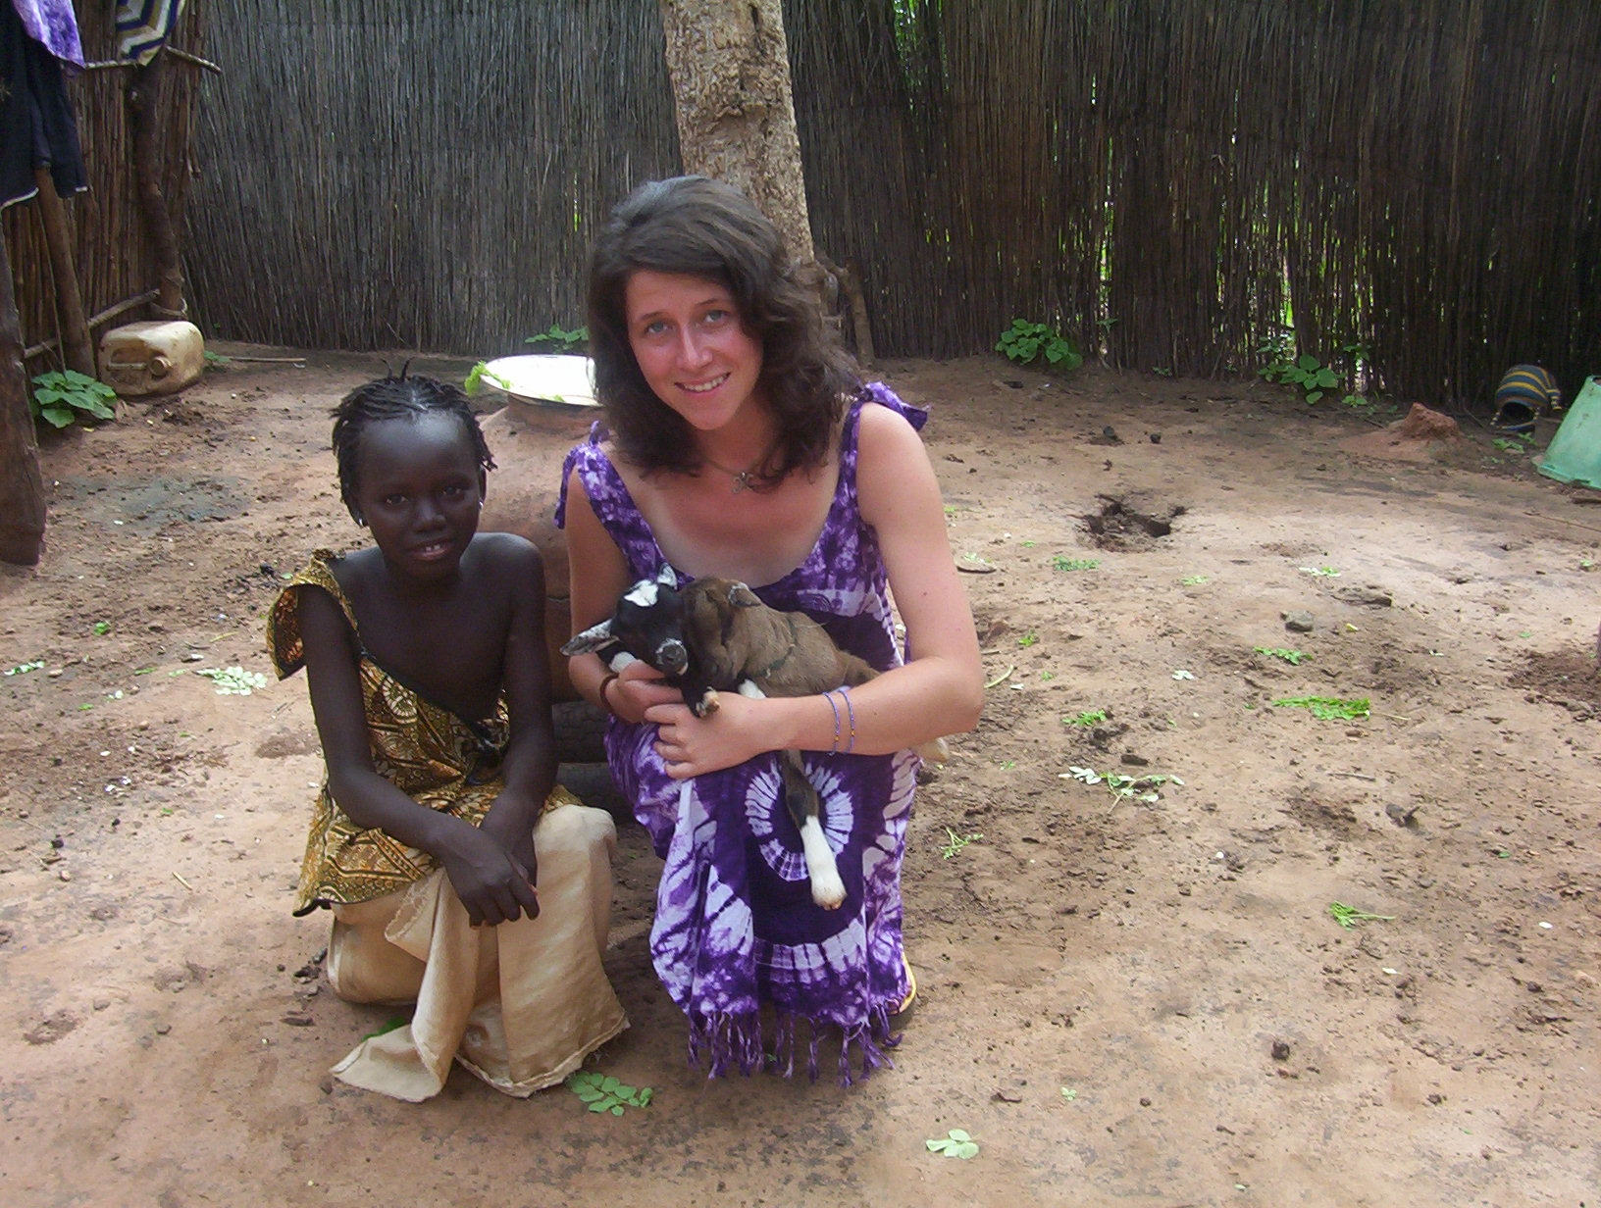
Background Bio:
Born and raised on a small, family operated dairy farm in Nova Scotia, I have developed a love for farming life and a desire to assist in developing and maintaining sustainable farming systems. Something inside of me always wanted to explore other cultures, step outside of my comfort zone and see who I really was in a situation I was unfamiliar with. My studies and work experiences have taken me on a path towards supporting sustainable agricultural practices from the ground. I believe in and am committed to the environment we live in and the people who inhabit it.
Education:
M.Sc., Dalhousie University
B.Sc. (Animal Science Major, Agribusiness Minor), Nova Scotia Agricultural College
Host Country: The Gambia

Internship Experience:
Summarizing six of the most incredible months of my life in a few paragraphs is definitely a challenge. I’ll give it a try. The structure of my placement consisted of two weeks language training in the village, two weeks of cultural integration in a neighboring village five months in Njawara village at the Njawara Agricultural Training Center (NATC) in the North Bank Division of the Gambia. During my homestay, I lived in a family compound in a village called Kerr Ardo. My days were spent in the field with the men, cooking with the women, playing with the children and working with the farmers on the Gambian Ecological Agricultural Development project. It was not always easy, at first. The transitional phase between letting go of the western culture I was brought up and absorbing and understanding the culture that presently surrounded me was something I have never experienced before. The day that I understood that they were not laughing at me, that they were in fact laughing with me and that, I too, could laugh freely with them was the day it all changed for me. That was the day the Gambia became my home and the Gambians became my family.

The role I played professionally in the village was to assist the project with trainings, to write reports and training modules, and to work with and learn from the farmers in the field. This was the most satisfying work experience I have ever had. At the end of the day, instead of a pile of papers on my desk after 8 hours in front of a computer screen as I would have had as an accomplishment in the “Western World”, I was able to feel like I have contributed, in a small way, to something more profound. To food security, to poverty alleviation, to the promotion of environmental awareness and preservation. At the end of the day I directly helped, with my bare hands, to put food on a family’s table. How incredible is that?

I was fortunate to have the opportunity to play a part in the development and production of the Mayon Turbo Stove in the Gambia. Working with local engineers and a technical welding shop, we were able to modify REAP-Canada’s existing MTS to meet Gambian cooking requirements. Driving in a truck, through upcountry West Africa, after weeks of hard work in the research and development, with a load of the first MTS in the country on the way to the villages for distribution was an extremely satisfying experience. It is impossible to describe in words the feeling of knowing I was able to contribute to the global village, to have a part in preventing deforestation, to help the environment and to assist in preventing potential respiratory illnesses in women.

On a personal level, I wore many hats with the villagers. Friend, sister, niece and daughter. Those people did not take long to find their way into my heart. They were my family. I have never met more caring and open people ever, nor can I imagine finding people like that anywhere else in the world. They were so easy to love. I learned so much from them. These people just took me in as if I was one of their own. They taught me to eat with my hands, to scrub my clothes in a bucket, to grow traditional crops, to take bucket showers and cook traditional food. They taught me the importance of sharing, patience and the value of unconditional acceptance. I feel very fortunate to have had this experience and to have been given to opportunity to learn so much about another culture and even more about myself.

Thank you Gambia.
